과제 B1-2

AI로 글·그림·영상 만들어 나만의 광고 만들기

I. 이미지 프롬프트
1. 마스터 디자인 - 정면, 측면, 후면, 3/4뷰, 후면
Positive prompt: AERION master vehicle design sheet, futuristic luxury flying sports sedan, metallic silver body, ultra aerodynamic design, hidden integrated micro-thrusters, no visible propellers, no helicopter blades, no wings, panoramic black glass canopy, ultra thin LED headlights, premium concept car, front view, side view, rear view, 3/4 perspective, industrial design presentation board, white studio background, photorealistic, Apple industrial design language, 8K, HDR

Negative Prompt: large propellers, drone, helicopter, airplane, robot, cartoon, toy, mechanical arms, multiple rotors, oversized engines, text, watermark

<GPT 이미지>
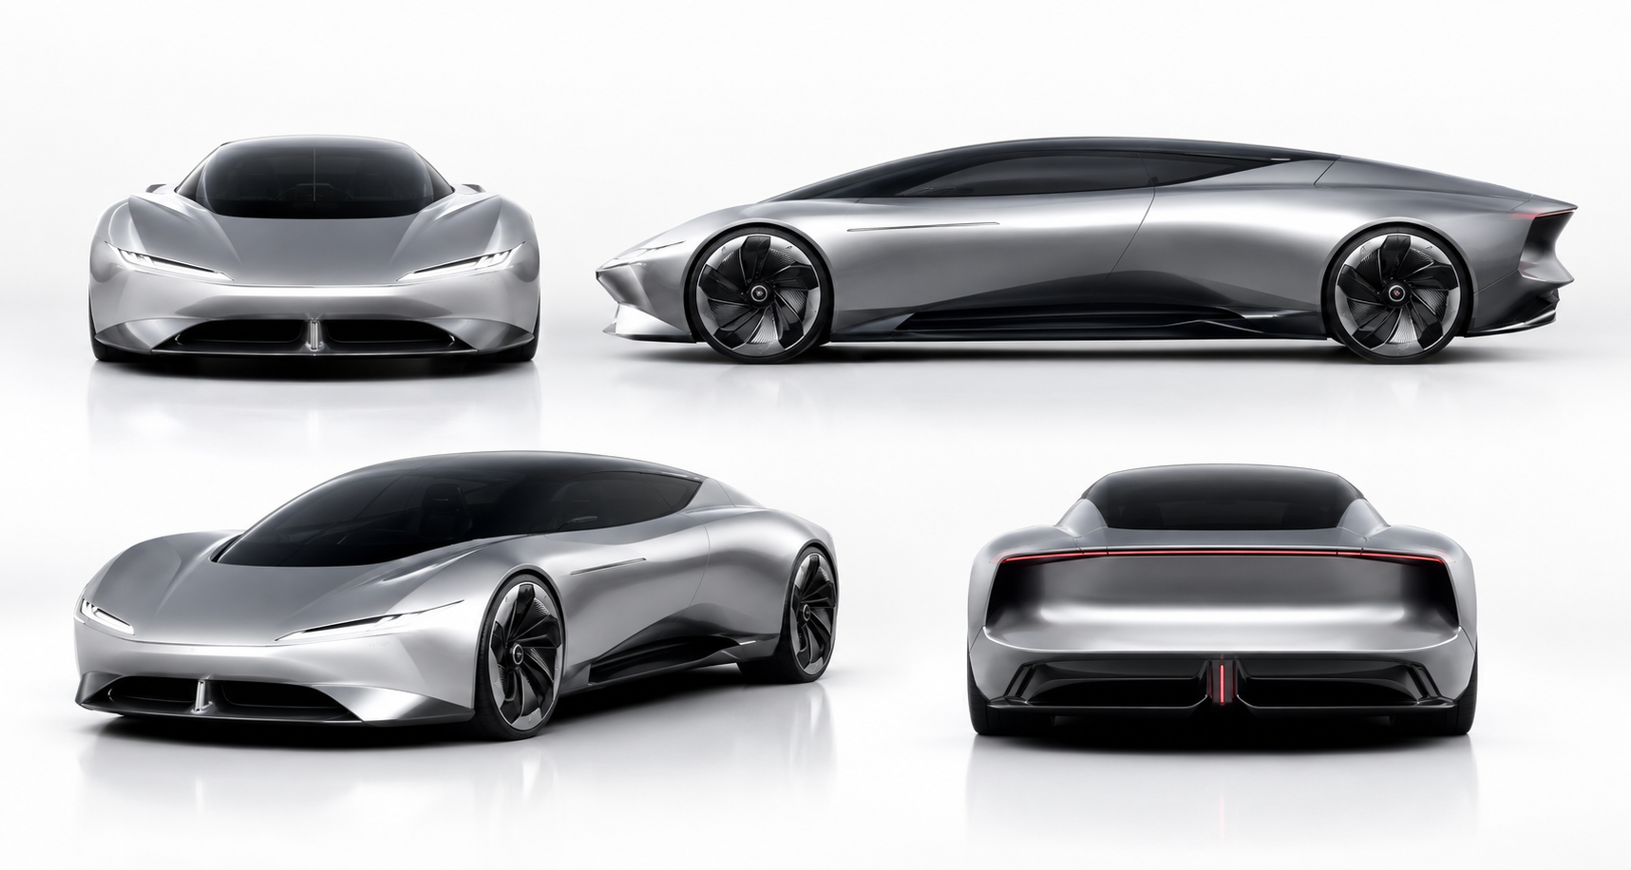

<Gemini 이미지>
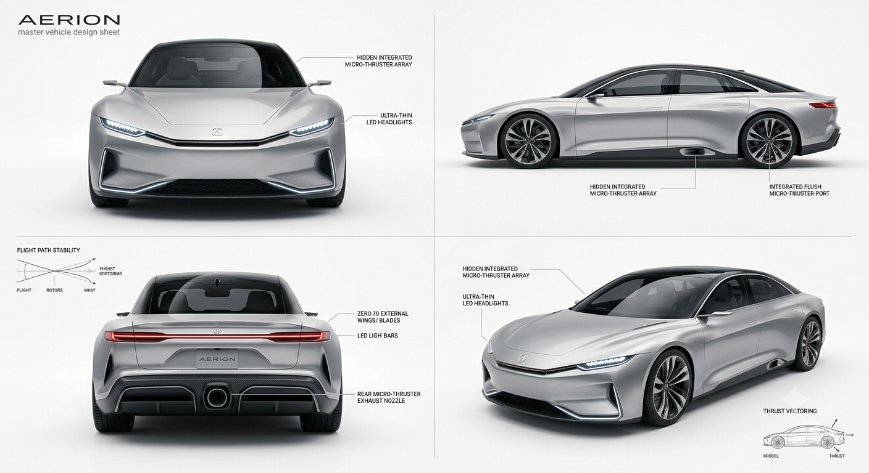

2. 영상 제작용 이미지 – 4컷
<공통 프롬프트>
AERION futuristic luxury flying sports sedan, metallic silver body, ultra aerodynamic body, hidden integrated micro-thrusters, no visible propellers, no helicopter blades, no airplane wings, panoramic black glass canopy, ultra-thin LED headlights, minimal luxury design, Apple industrial design language, Genesis luxury concept, BMW Vision Next inspiration, photorealistic, premium automotive commercial, 8K, HDR, physically accurate materials

2-1. Image 1 - Scene 1 (현재의 한계)
AERION futuristic luxury flying sports sedan, metallic silver body, ultra aerodynamic body, hidden integrated micro-thrusters, no visible propellers, no helicopter blades, no airplane wings, panoramic black glass canopy, ultra-thin LED headlights, minimal luxury design, Apple industrial design language, Genesis luxury concept, BMW Vision Next inspiration, photorealistic, premium automotive commercial, 8K, HDR, physically accurate materials

Positive Prompt: The AERION is completely trapped inside an extremely dense multi-lane traffic jam in a futuristic megacity during golden hour. Hundreds of premium luxury sedans and SUVs completely surround the AERION in every direction, cars directly in front, behind, left and right with almost no empty space, bumper-to-bumper traffic, no visible open road ahead. Rear follow camera from another vehicle, the hood of the camera car slightly visible at the bottom edge, centered composition, the AERION positioned in the middle of endless traffic. Wet asphalt reflecting sunset, glowing brake lights everywhere, cinematic volumetric lighting, dramatic orange sunset mixed with cool blue city reflections, towering glass skyscrapers, digital billboards, realistic lens flare, premium automotive commercial, ultra photorealistic, HDR, 8K, physically accurate materials.

negative prompt: large propellers, drone, helicopter, airplane wings, robot, cartoon, anime, toy, flying, hovering, empty road, wide spacing between vehicles, people, pedestrians, motorcycles, buses, watermark, logo, text, blurry, low quality, oversaturated

Reference:
Positive prompt: AERION master vehicle design sheet, futuristic luxury flying sports sedan, metallic silver body, ultra aerodynamic design, hidden integrated micro-thrusters, no visible propellers, no helicopter blades, no wings, panoramic black glass canopy, ultra thin LED headlights, premium concept car, front view, side view, rear view, 3/4 perspective, industrial design presentation board, white studio background, photorealistic, Apple industrial design language, 8K, HDR
Negative Prompt: large propellers, drone, helicopter, airplane, robot, cartoon, toy, mechanical arms, multiple rotors, oversized engines, text, watermark
<GPT 이미지>
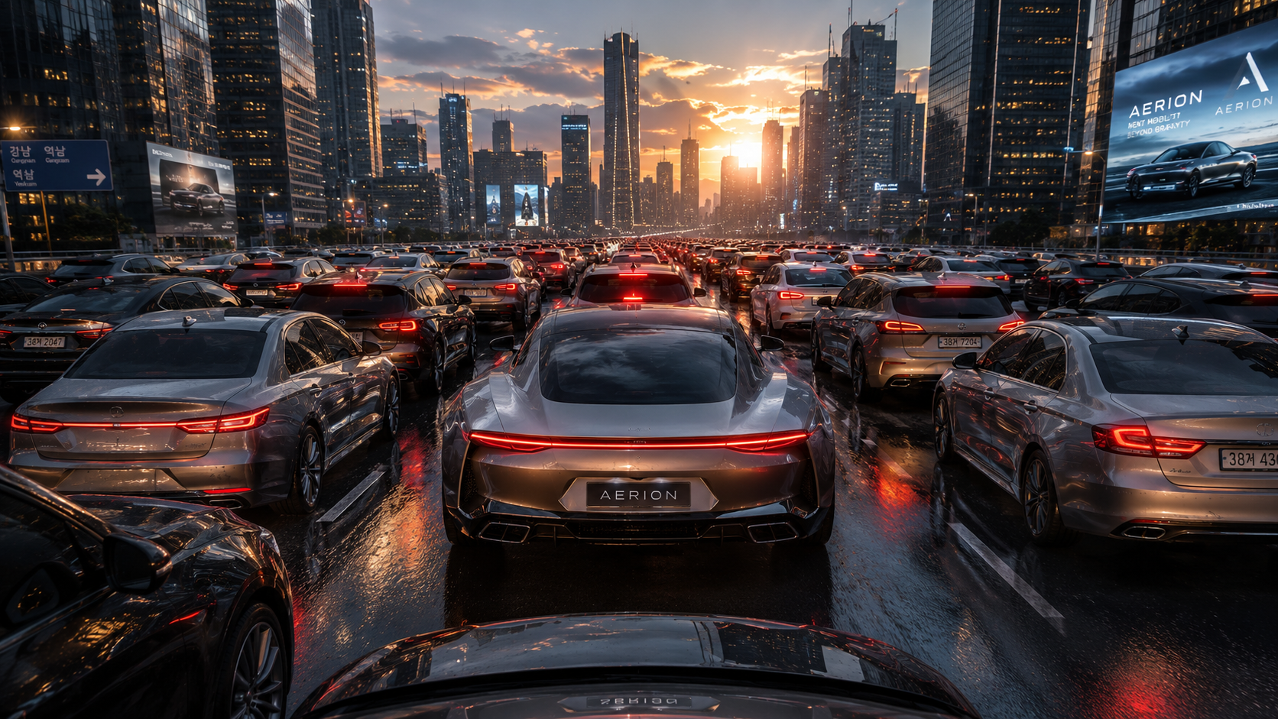

<Gemini 이미지>
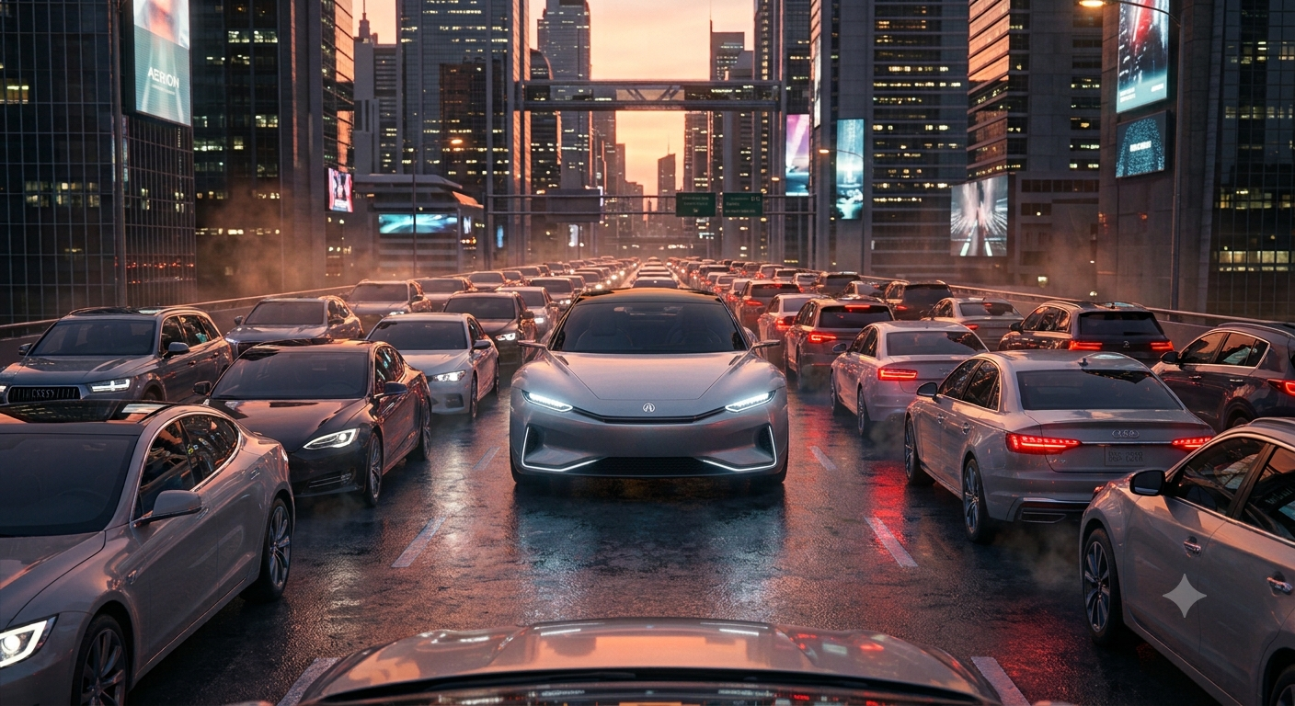

2-2. Image 2 - Scene 2(혁신의 시작)
AERION futuristic luxury flying sports sedan, metallic silver body, ultra aerodynamic body, hidden integrated micro-thrusters, no visible propellers, no helicopter blades, no airplane wings, panoramic black glass canopy, ultra-thin LED headlights, minimal luxury design, Apple industrial design language, Genesis luxury concept, BMW Vision Next inspiration, photorealistic, premium automotive commercial, 8K, HDR, physically accurate materials

positive prompt: AERION futuristic luxury flying sports sedan, metallic silver body, ultra aerodynamic body, hidden integrated micro-thrusters, no visible propellers, no helicopter blades, no airplane wings, panoramic black glass canopy, ultra-thin LED headlights, minimal luxury design, Apple industrial design language, Genesis luxury concept, BMW Vision Next inspiration, photorealistic, premium automotive commercial, HDR, physically accurate materials.
The AERION is lifting vertically from the center of a completely gridlocked multi-lane highway inside a futuristic smart megacity. Hundreds of premium vehicles remain completely stationary, bumper-to-bumper traffic, cars tightly packed in front, behind, left and right, nobody moves, no vehicles making space, realistic traffic congestion. The AERION rises approximately one meter above the road surface while maintaining a perfectly level attitude. Soft blue anti-gravity energy beams project downward beneath the vehicle, forming a circular holographic energy field on the asphalt. Hidden micro-thrusters emit subtle blue plasma glow from underneath the body without visible flames. The surrounding vehicles remain untouched and unmoved, emphasizing that only the AERION is capable of escaping the traffic. Golden hour sunset, warm orange sunlight mixed with cool blue energy illumination, wet asphalt reflecting blue light and red brake lights, cinematic volumetric lighting, realistic reflections, dramatic perspective, centered composition, premium futuristic automotive commercial, Apple keynote aesthetic, ultra photorealistic, 8K, HDR, ray tracing, physically accurate materials.
negative prompt: large propellers, rotor, drone, helicopter, airplane, robot, cartoon, extra wheels, mechanical arms, low quality, watermark large propellers, rotors, drone, helicopter, airplane wings, jet engines, robot, cartoon, anime, hovercraft, flying taxi, surrounding cars moving away, empty road, wide spacing between vehicles, explosion, fire, smoke, people, pedestrians, motorcycles, buses, watermark, logo, text, low quality, blurry, oversaturated, deformed vehicle, extra wheels
Reference:
Positive prompt: AERION master vehicle design sheet, futuristic luxury flying sports sedan, metallic silver body, ultra aerodynamic design, hidden integrated micro-thrusters, no visible propellers, no helicopter blades, no wings, panoramic black glass canopy, ultra thin LED headlights, premium concept car, front view, side view, rear view, 3/4 perspective, industrial design presentation board, white studio background, photorealistic, Apple industrial design language, 8K, HDR

Negative Prompt: large propellers, drone, helicopter, airplane, robot, cartoon, toy, mechanical arms, multiple rotors, oversized engines, text, watermark
<GPT 이미지>
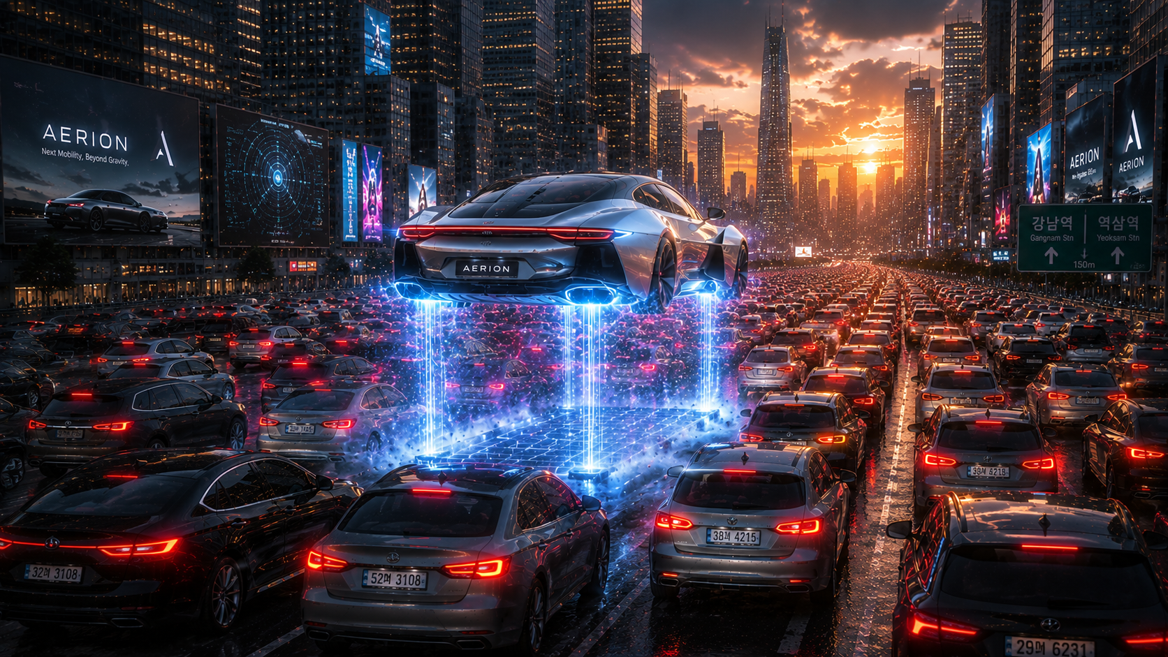

<Gemini 이미지>
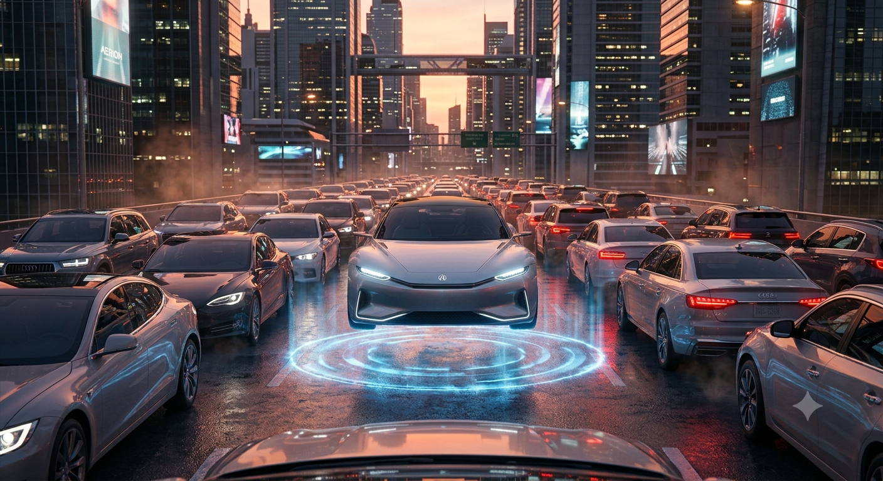

2-3. Image 3 - Scene 3(하늘을 가르다)
AERION futuristic luxury flying sports sedan, metallic silver body, ultra aerodynamic body, hidden integrated micro-thrusters, no visible propellers, no helicopter blades, no airplane wings, panoramic black glass canopy, ultra-thin LED headlights, minimal luxury design, Apple industrial design language, Genesis luxury concept, BMW Vision Next inspiration, photorealistic, premium automotive commercial, 8K, HDR, physically accurate materials

positive prompt: AERION futuristic luxury flying sports sedan, metallic silver body, hidden integrated micro-thrusters, ultra aerodynamic body, flying at high speed between futuristic skyscrapers, dynamic banking turn, motion blur, energy trails, bright futuristic city, golden hour, volumetric sunlight, cinematic aerial tracking shot, luxury automotive commercial, extreme realism, Apple keynote, Top Gun Maverick atmosphere, 8K, HDR

negative prompt: large propellers, drone, helicopter, airplane, robot, cartoon, people, text, watermark, low quality, slow motion

Reference:
Positive prompt: AERION master vehicle design sheet, futuristic luxury flying sports sedan, metallic silver body, ultra aerodynamic design, hidden integrated micro-thrusters, no visible propellers, no helicopter blades, no wings, panoramic black glass canopy, ultra thin LED headlights, premium concept car, front view, side view, rear view, 3/4 perspective, industrial design presentation board, white studio background, photorealistic, Apple industrial design language, 8K, HDR
Negative Prompt: large propellers, drone, helicopter, airplane, robot, cartoon, toy, mechanical arms, multiple rotors, oversized engines, text, watermark

<GPT 이미지>
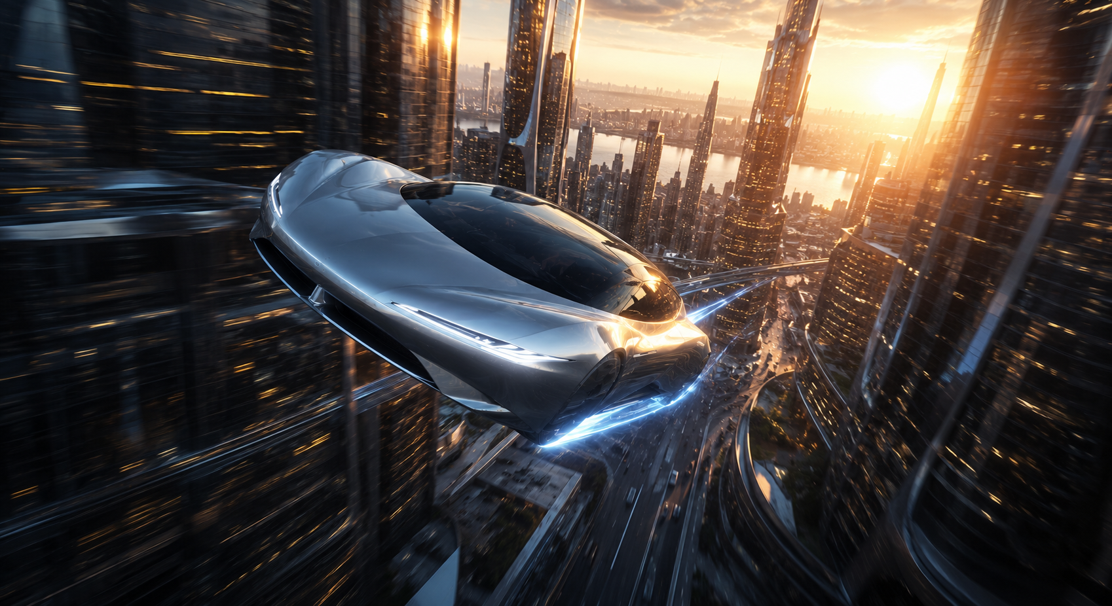

<Gemini 이미지>
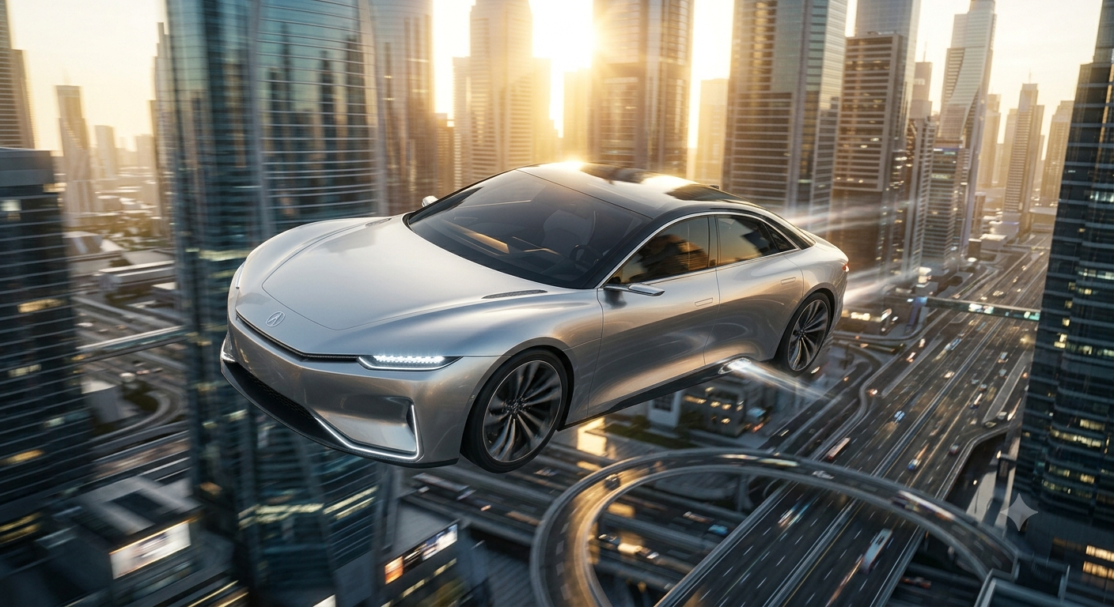

2-4. Image 4 - Scene 4(브랜드엔딩, w/카피)
AERION futuristic luxury flying sports sedan, metallic silver body, ultra aerodynamic body, hidden integrated micro-thrusters, no visible propellers, no helicopter blades, no airplane wings, panoramic black glass canopy, ultra-thin LED headlights, minimal luxury design, Apple industrial design language, Genesis luxury concept, BMW Vision Next inspiration, photorealistic, premium automotive commercial, 8K, HDR, physically accurate materials

ray tracing, global illumination, premium metallic reflections. Hero shot, vehicle floating peacefully above bright white clouds, golden sunrise, warm orange sunlight, clean blue sky, soft volumetric lighting, cinematic atmosphere, minimal composition, vehicle positioned on the right side, front three-quarter view,
slight nose-up angle, luxury concept vehicle, calm and elegant mood, Apple Keynote presentation aesthetic,
high-end automotive commercial.
Typography layout: Large premium white typography placed on the left side.
Top: "AERION" very large, thin modern sans-serif, wide letter spacing, clean Apple-style typography.
Middle: "Next Mobility, Beyond Roads" approximately 60–70% of the size of AERION, larger than the CTA, medium font weight, high readability, balanced spacing.
Bottom: "Reserve Your Future" approximately 40–45% of the size of AERION, smaller than the tagline, light font weight, minimal premium style.
Clear visual hierarchy, ample negative space, perfect alignment, balanced composition between typography and vehicle, luxury advertisement layout, no distortion, no cropped vehicle.
Negative Prompt: large propellers, drone, helicopter, airplane, airplane wings, robot, cartoon, anime,
toy, mechanical arms, multiple rotors, oversized engines, people, buildings, city, mountains, text errors, misspelled typography, blurry letters, small text, low contrast text, watermark, logo artifacts, low quality, low resolution, oversaturated, deformed vehicle, extra wheels, cropped car

<GPT 이미지>
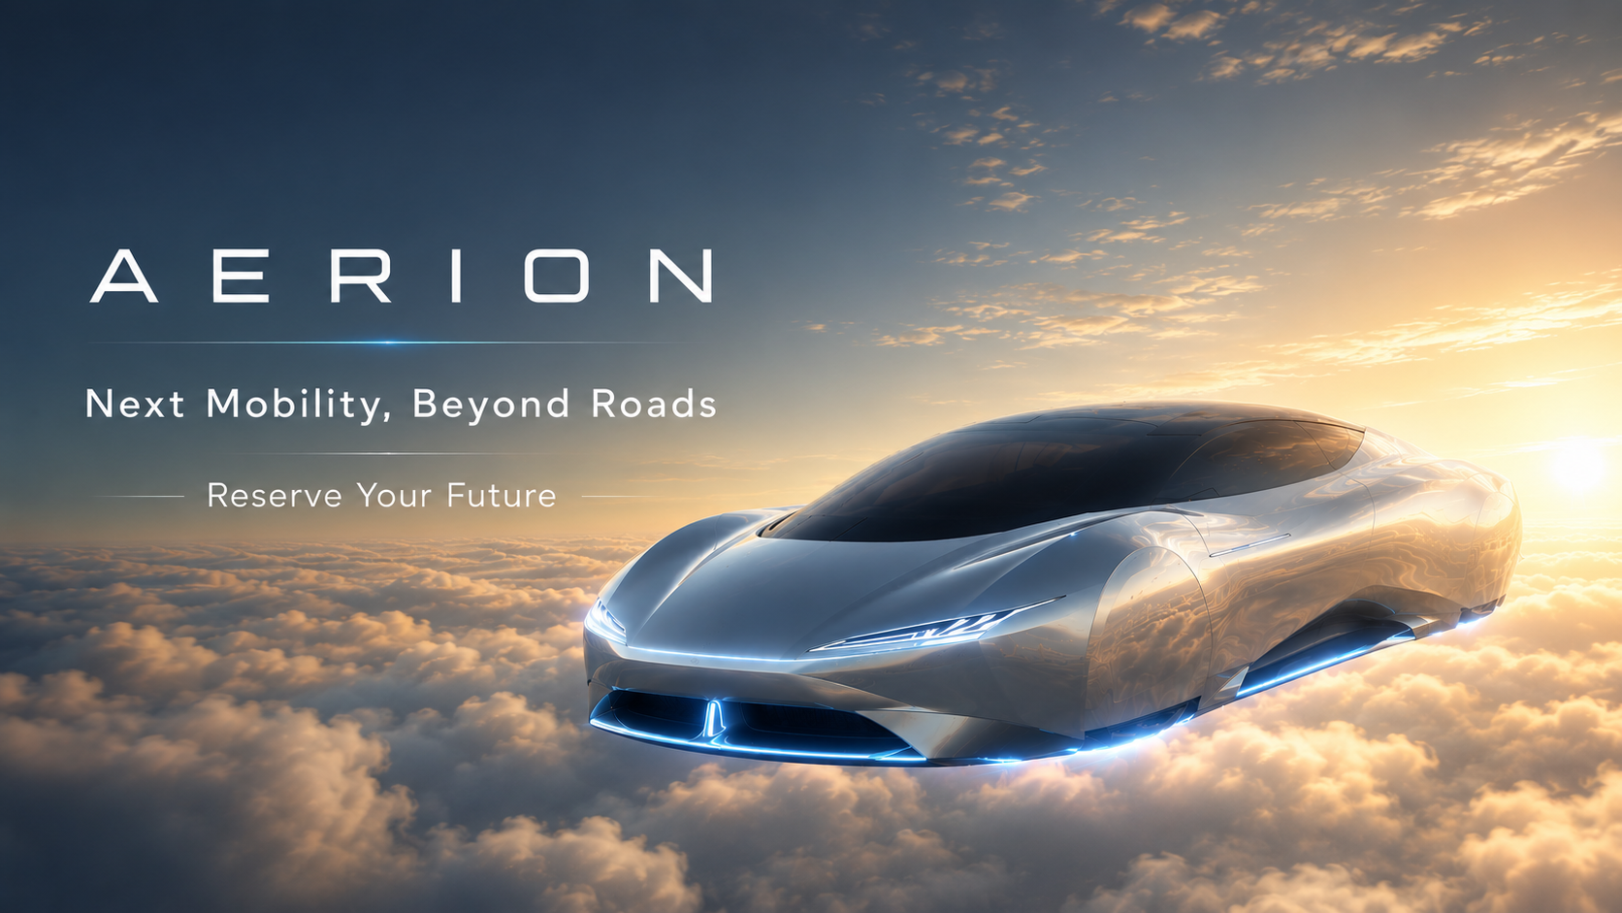

<Gemini 이미지>
